**Startup India Registration -**

**add 1 -**



**Startup India Registration.**

Startup India Registration: Your Gateway to Government Benefits and Growth Opportunities

Unlock the Advantages of Startup India Registration: Tax Exemptions, Funding Access, and More

Add 2 –

**Startup India Registration – Empowering Innovation**



**Startup India Registration**, launched in 2016, supports startups with tax benefits, funding, and simplified compliance. Eligible startups (under 10 years old, turnover below ₹100 crore) gain reduced IP filing costs, fast patent approvals, and tender access.

**Key Objectives:**

* **Funding Support**: Financial aid for growth.
* **Industry Partnerships**: Collaboration and incubation support.
* **Simplified Processes**: Guidance for seamless scaling.

add 3 –

**What is the Startup India Scheme?**



Launched on January 16, 2016, the Startup India Scheme aims to make India a global hub for innovation and entrepreneurship. Managed by DPIIT, it supports startups with funding, mentorship, and business-friendly regulations to foster growth and eliminate barriers.

**Benefits of the Startup India Scheme**

1. **Tax Exemptions**: Startups enjoy a 3-year tax holiday and exemptions on capital gains, reducing financial burdens.
2. **Funding Support**: Access to government-backed funds and seed funding to accelerate growth and innovation.
3. **Simplified Compliance**: Self-certification for labor and environmental laws, along with single-window clearance for approvals.
4. **Faster IP Processing**: Up to 80% rebate on patent costs and expedited intellectual property rights processing.

add 4 – Eligibility Criteria for Startup India Registration.

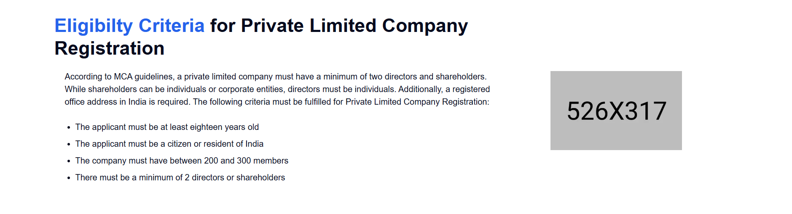

To be eligible for Startup India recognition, your business must meet the following criteria:

1. **Incorporation:** Your business must be incorporated as a Private Limited Company, Partnership Firm, or Limited Liability Partnership.
2. **Age:** Your business should not be older than 10 years from the date of incorporation.
3. **Annual Turnover:** The annual turnover of your business should not exceed Rs. 100 crore in any financial year.
4. **Innovation and Scalability:** Your business should be innovative and have the potential for significant growth and job creation.

Add 5 -

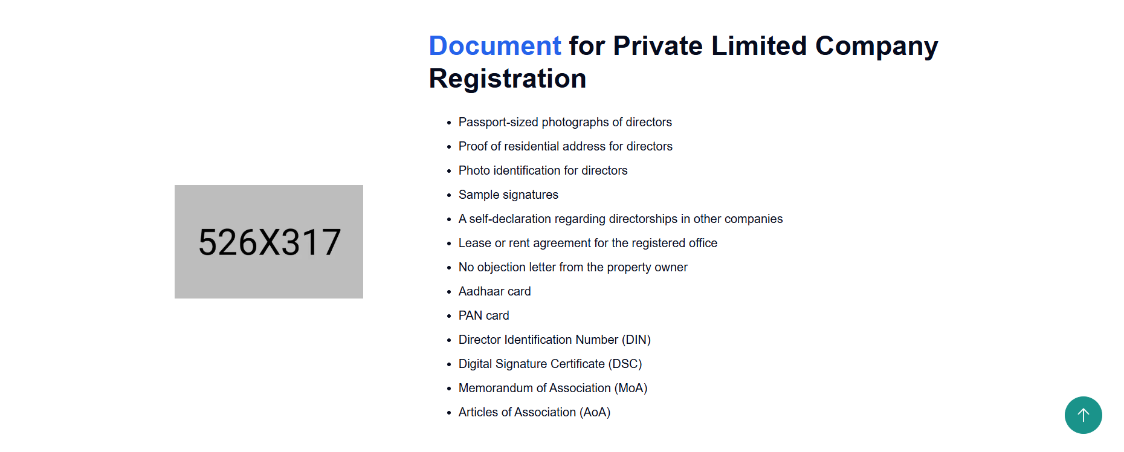

**Required Documents for Startup India Registration**

To register your startup under the Startup India Initiative, you'll need:

* **Company Incorporation Certificate**
* **Proof of Funding (if applicable)**
* **Authorization Letter**
* **Business Plan or Pitch Deck**
* **Intellectual Property Details (patents, trademarks)**
* **Awards and Recognitions**
* **PAN Card**

Ensure your startup meets eligibility criteria to avail of benefits.

Add 6 –



**Startup India Registration Fees: A Breakdown**

**Base Fee:**

* A nominal fee is typically charged for registering your startup under the Startup India Scheme.

**Additional Costs:**

* **Professional Fees:** You may incur charges for consulting services, legal fees, and documentation costs.

**Government Support:**

* The government offers subsidies and waivers to reduce the financial burden on startups.
* You may be eligible for discounts on patent and trademark filings.

**Note:** Fees and regulations may change over time. It's advisable to consult the official Startup India portal for the most accurate and up-to-date information.

Add 7 -

**Effortlessly Register Your Startup with Startup India**

**Streamline your Startup India registration with this 4-step guide!**

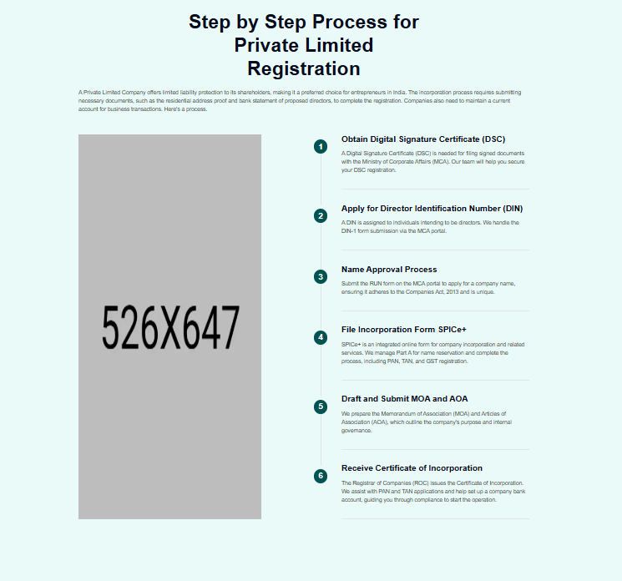

**Use the same image which is used in other pages for steps**

**1. Register Your Business Entity:**

* Incorporate your business as a Private Limited Company, Partnership Firm, or Limited Liability Partnership (LLP) with the Ministry of Corporate Affairs (MCA) or Registrar of Firms.

**2. Create Your Startup India Profile:**

* Head to the official Startup India portal (startupindia.gov.in) and register for an account.
* Fill out your profile details accurately, including incorporation information, business address, and industry sector.

**3. Apply for DPIIT Recognition:**

* Once your profile is complete, submit an online application for DPIIT (Department for Promotion of Industry and Internal Trade) certification.
* Attach necessary documents like your Certificate of Incorporation, business plan, and financial statements.
* Upon approval, you'll receive a unique recognition number, officially registering your startup.

**4. Finalize Your Application:**

* Before submitting, carefully review the completion checklist to ensure all information is accurate and documents are uploaded correctly.
* Double-check that all required forms are filled out and your contact details are up-to-date. This minimizes errors and expedites the approval process.

Add 8 –

**DPIIT Recognition: Key Benefits for Your Startup**

**DPIIT recognition unlocks a range of benefits for your startup, fostering growth and innovation. Here are some key advantages**

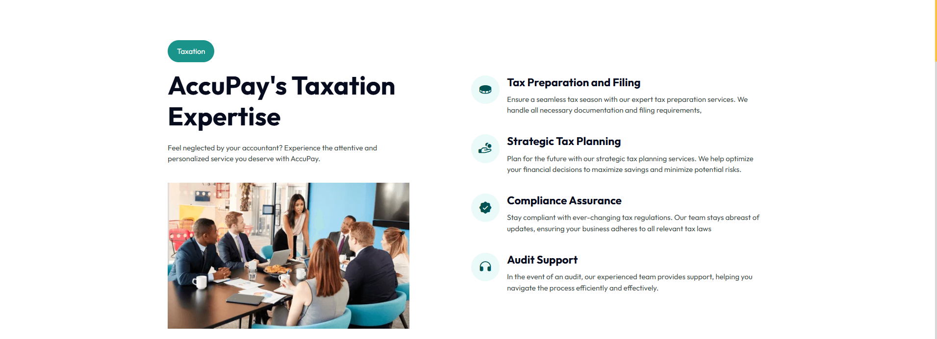

**1. Tax Incentives:**

* Income Tax Exemptions (Section 80IAC): Avail income tax exemptions and capital gains tax relief, allowing for reinvestment in your business.
* Tax Relief on Investments (Section 56(2)(VIIB): Receive exemptions on investments from eligible investors, boosting your funding potential.

2. **Streamlined Patent and IPR Processes:**

* Fast-Track Applications: Expedite your patent, trademark, and design applications.
* Reduced Costs: Benefit from government subsidies and rebates on filing fees.

3. **Simplified Winding-Up Process:**

* Faster Closure: Streamline the closure process for startups with simple debt structures.
* Efficient Asset Liquidation: Ensure a quicker recovery of capital.

4. **Enhanced Market Access:**

* Simplified Government Procurement: Participate in government tenders without meeting prior experience or turnover criteria.
* Reduced Entry Barriers: Benefit from exemptions on Earnest Money Deposits for government contracts.

Add 9- Remove this

**How Ensurekar Can Help After Startup India Registration**

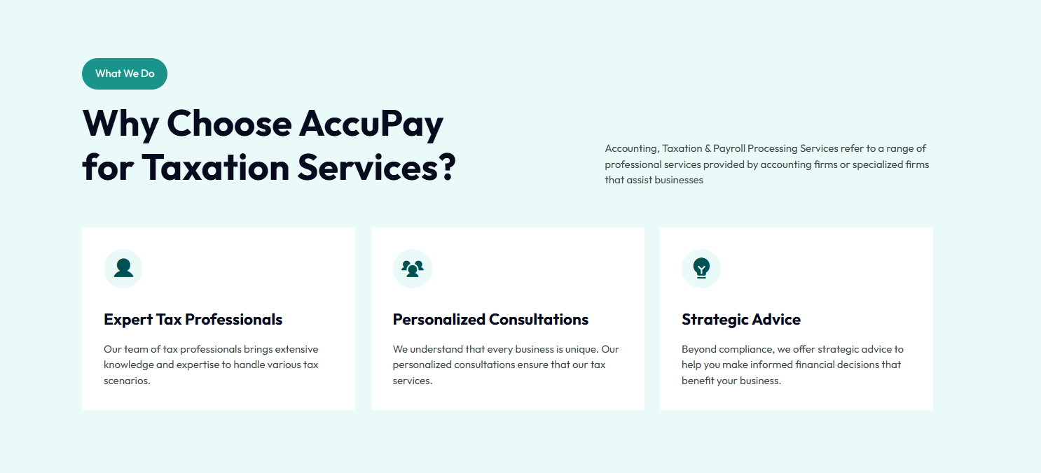

Make this in 5 tabs

Ensurekar provides ongoing support to ensure your compliance with all Startup India requirements. We'll assist with:

* **Annual Filings:** Timely submission of all necessary annual filings.
* **Tax Exemptions:** Maintaining and maximizing your tax exemptions and benefits.
* **Regulatory Compliance:** Ensuring your business remains compliant with all relevant regulations.
* **IPR Protection:** Assisting with the filing and maintenance of intellectual property rights.
* **Stay Updated:** Keeping you informed about any changes in regulations or policies.

Add 10 – add FAQ

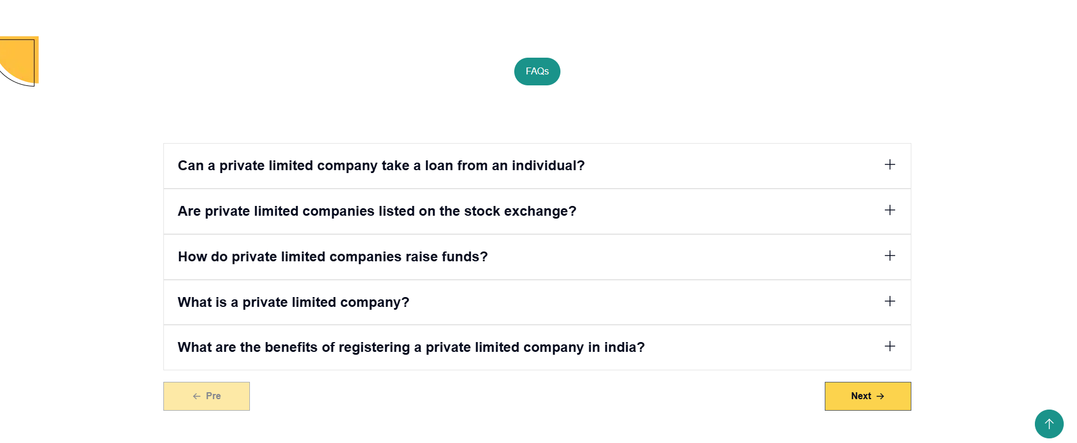

These are excellent questions! Here are the rephrased FAQs for better clarity and SEO:

**1. How does Startup India differ from other startup schemes?**

**2. Can a foreign-owned company register under Startup India?**

**3. What is the role of incubators in the Startup India Scheme?**

**4. Is there a time limit for applying for Startup India registration?**

**5. How does Startup India support startups in funding?**

**6. What types of businesses are excluded from the Startup India Scheme?**

**7. How does DPIIT recognition help in international expansion?**

**8. What are the benefits of the Startup India scheme for women entrepreneurs?**

**9. What are the tax exemptions under Startup India?**

**Here are the images which you have to change –**

1.  




2.





3.





4.



5.





6.



